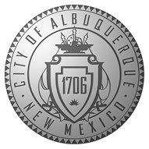 |  | 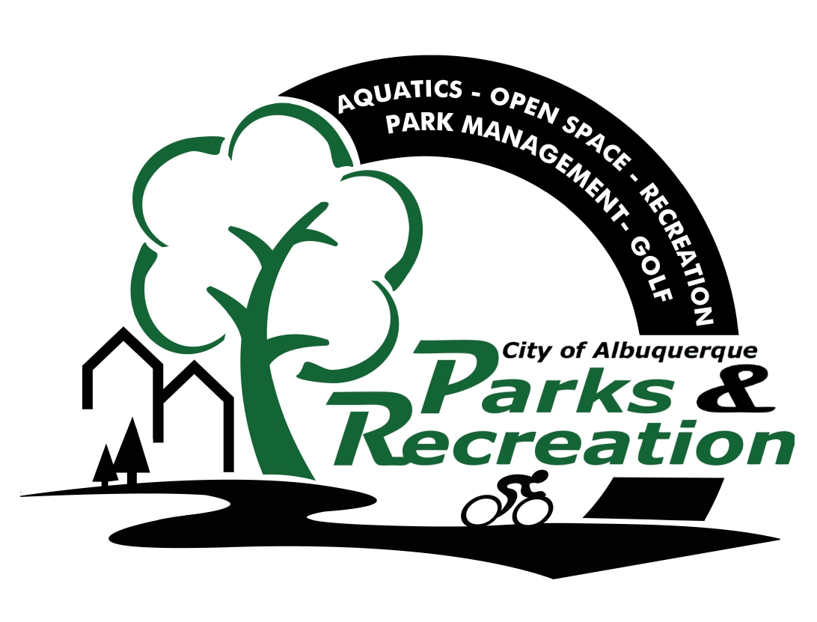

2017 Warrior Sports Program Activity Descriptions
For more information call Catherine Ivie at 505-366-2030

Pickleball Lessons/Scrimmages
A sport that is sweeping the country: tennis, badminton & table tennis all in one. Easier on the body than other court sports.
- Meet 11:30am at Manzano Mesa Multigenerational Center: 501 Elizabeth St. SE Albuquerque, New Mexico 87123, event is 12:30-2:50pm

Mountain Bike trips to the Bosque
Join us in experiencing the Albuquerque Bosque on two wheels. Try mountain biking through the heart of the city, with these 4-6 mile group rides. Please come prepared with water and dressed appropriately for the weather. Mountain bike group rides are limited to 10 participants, and all riders must be above 16 years of age. Helmets will be provided and must be worn.
- Meet 9:00am at the Tingley Beach North (Dirt) Parking Lot

Golf
Join us at the Golf Center at Balloon Fiesta Park to hit a bucket of balls at the Driving Range and play the 6-Hole par 3 walking course (unlimited play). Unstructured, enjoy at your own pace! Lessons are available at a fee upon request.
- Meet at 9:30am at Golf Center, 9401 Balloon Museum Drive NE, 87113

Snowshoe Trips
Winter snowshoe trips to Santa Fe Ski Area! Vans will pick participants up at the VA Hospital and drive to the Santa Fe Ski Area. Package price includes snowshoes and transportation. Wear warm waterproof clothing, boots and gloves.
- Meet at the VA Hospital at 7:00am. Trip will return to the VA at approximately 5:30pm (depending on traffic)

Watch for information coming this spring for the summer sports!

